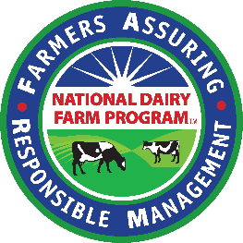

|  |  |
| --- | --- |
| **FOR IMMEDIATE RELEASE** | Alan Bjerga |
| Thursday, April 4, 2019 | (703) 243-6111 ext. 372 |
|  | [ABjerga@nmpf.org](mailto:ABjerga@nmpf.org) |

# 

**FARM Program Statement: Martin Farms, Inc.***From Emily Yeiser Stepp, Senior Director, FARM Animal Care Program:*

ARLINGTON, VA – “The National Dairy Farmers Assuring Responsible Management (FARM) Program has established a rigorous framework of best practices to ensure the proper treatment of dairy animals. The program – created by veterinarians, animal welfare experts and farmers – takes seriously all allegations of mistreatment of dairy cattle.

“We were initially notified by Maryland & Virginia Milk Producers Cooperative Association Inc. that one of their member farms, Martin Farms, had allegations of animal mistreatment made against them. The cooperative requires participation in and full compliance with the FARM Program by every farmer-member. In response, we immediately activated FARM’s willful mistreatment protocol and initiated a third-party audit of its animal-care practices on March 9. The video that prompted the initial allegations was made available to us on March 13. The video shows instances of willful mistreatment, and the FARM Program placed the farm on probation. Martin Farms must take immediate corrective actions to be reinstated into good standing with the program.

“As a program created to establish and improve best practices across the dairy industry, we are deeply disturbed by the mistreatment shown in the video and are committed to ensuring that animal care remains the highest priority by all dairy farmers.”

###

The National Milk Producers Federation (NMPF), based in Arlington, VA, develops and carries out policies that advance the well-being of dairy producers and the cooperatives they own. The members of NMPF’s cooperatives produce the majority of the U.S. milk supply, making NMPF the voice of dairy producers on Capitol Hill and with government agencies. For more on NMPF’s activities, visit our website at [www.nmpf.org](http://www.nmpf.org).