March 7, 2017
national milk producers federation
2107 wilson blvd., suite 600, arlington, va 22201
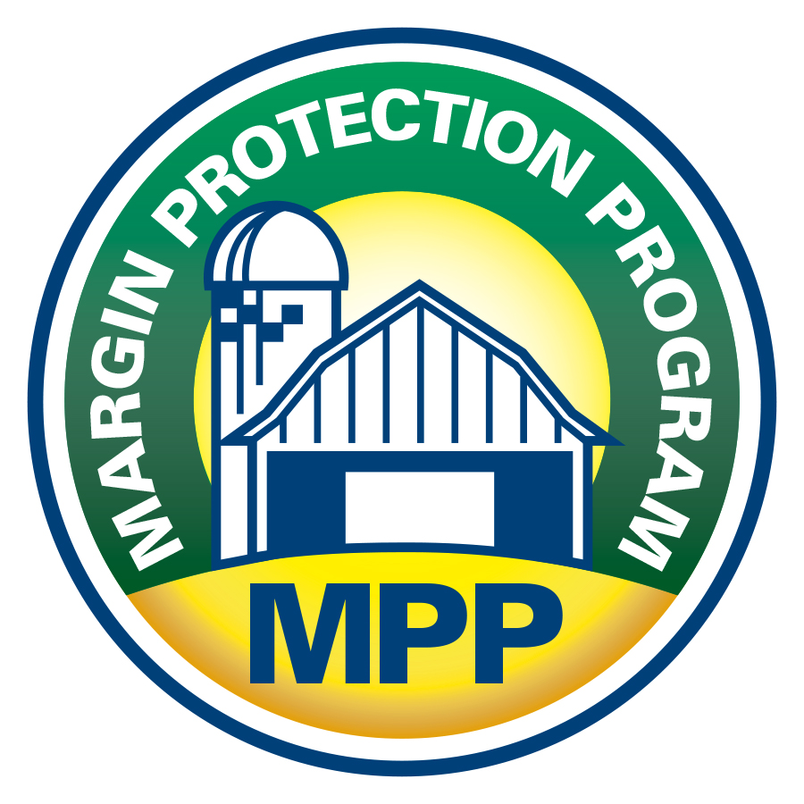

RECOMMENDATIONS TO THE NMPF BOARD OF DIRECTORS
FROM THE NMPF ECONOMIC POLICY COMMITTEE
EXECUTIVE SUMMARY
RECOMMENDED IMPROVEMENTS TO THE
DAIRY MARGIN PROTECTION PROGRAM
MARGIN PROTECTION PROGRAM
The NMPF Economic Policy Committee has approved a comprehensive package of recommended changes to the Margin Protection Program for Dairy, all of which will help improve its effectiveness for dairy farmers. Below is a summary list of those recommendations:
ISSUE: Validity of the original feed cost formula developed by NMPF
POSITION: The 10-percent feed formula reduction from the original NMPF proposal should be restored to its originally proposed levels so the program operates as intended.

ISSUE: Use of the corn price series from USDA’s Agricultural Marketing Service
POSITION: The source of the corn price in the feed formula should be changed from NASS to AMS, and NMPF should work with AMS to improve data collection.

ISSUE: NASS alfalfa price and the cost of purchasing dairy-quality hay
POSITION: NMPF should discuss with Congress, NASS and AMS the need to evaluate the collection and usage of dairy hay reporting.

ISSUE: Using a national average price for soybean meal
POSITION: The source of the soybean meal price in the MPP feed formula should be modified from the Decatur-Central Illinois pricing point to the average of all pricing points reported by AMS.
ISSUE: Accuracy and affordability of MPP premium rates
POSITION: Premiums should be adjusted to incentivize increased producer participation in the program while balancing premium costs in a way that manages overall MPP budget costs.

ISSUE: Accuracy of the U.S. all-milk price as a proxy for farm-level prices
POSITION: NMPF should assess with NASS and AMS ways the calculation of both the all-milk price and the mailbox milk price could be improved (including more timely and inclusive calculations).
ISSUE: Frequency of margin determinations
POSITION: MPP payments should be determined on a monthly basis, rather than bi-monthly.
ISSUE: Timing for annual sign-up
POSITION: MPP should provide producers with greater flexibility for signing up for coverage for the upcoming year.
ISSUE: Expansion and compatibility of Livestock Gross Margin program with MPP
POSITION: Improvements to the LGM should be incorporated as part of the NMPF Farm Bill request to Congress, with the goal of significantly expanding the cap for dairy and ensuring LGM works in a complementary manner with MPP.
NMPF Position on Improving the Margin Protection Program
for Dairy (MPP-Dairy)

GENERAL BACKGROUND
The Margin Protection Program-Dairy (MPP-Dairy) was developed by the National Milk Producers Federation (NMPF) through a lengthy, detailed and deliberative process in response to the dairy industry financial crisis of 2009. Despite the helpful response to that crisis by the Secretary of Agriculture to maximize the use of the existing federal farm program’s safety net elements, i.e. the Dairy Product Price Support Program, the Dairy Export Incentive Program and the Milk Income Loss Contract Program (MILC), these programs failed to provide the protection U.S. dairy farmers required. In the aftermath of this experience, NMPF developed the Foundation for the Future program, which included MPP-Dairy, to replace these ineffective safety net programs.
Congress accepted NMPF’s proposal as the template for the dairy safety net program in the “2012” farm bill, but when it was eventually enacted in 2014, the MPP had been amended and diluted to the extent that it, too, fell short of providing the protection required of an effective farm safety net program. Following MPP’s enactment into law, the U.S. Department of Agriculture (USDA) again did an excellent job of implementing the program to make it as useful as possible. However, too many of the program’s key features were locked into place by legislative language – thus frustrating even USDA’s best efforts to make it into an effective safety net program providing adequate protection for participating dairy producers’ milk price over feed cost margins. In just two full years of operation, participation at the higher coverage levels under the program has dropped substantially, due in large part to the program not functioning as intended. Correcting the current program’s deficiencies will require legislative changes, changes that are essential to ensuring that U.S. dairy producers have a federal farm program in Title I that can be effective for years to come.
Over the last two years, NMPF staff gathered feedback on the program from producers across the country. Subsequently, NMPF’s officers developed a set of guiding principles that directed NMPF to begin a process to address the program’s deficiencies. At the 2016 NMPF Annual Meeting, NMPF staff presented this planning process to the producer community. NMPF Chairman Randy Mooney re-established the Economic Policy Committee (EPC), including producers and co-op staff from across the country, to review the program and suggest possible improvements. The EPC met twice in recent months, and finalized its recommendations to the NMPF Board of Directors on Feb. 14.
In addition to this internal process, NMPF met with key members of Congress and key leaders in agriculture to explain the group’s process and desire to make changes to the MPP as soon as possible.
As noted, the original MMP was developed by dairy farmers working together following the 2009 milk price debacle. This MPP review has followed a similar process, and the Economic Policy Committee’s recommendations are designed to address limitations of the current program in a manner that can gain broad support from the dairy producer community from coast to coast.

RECOMMENDATION NO. 1
Issue: validity of the original feed cost formula developed by NMPF
During its deliberations on the 2014 farm bill, Congress made a random, 10-percent cut to the weightings of all three feedstuff components of the MPP-Dairy feed cost formula, based on an arbitrary budget cost analysis by the Congressional Budget Office that is required as a component of the legislative process. NMPF developed the original feed cost formula with great care, using the resources of professional dairy cattle nutritionists, academic experts, a panel of NMPF member dairy producers and NMPF staff. The current, diluted, MPP-Dairy feed cost formula understates the cost of feed to produce 100 pounds of milk, thereby overstating the milk price over feed cost margin, reducing program payments to producers.

BACKGROUND
Using monthly data between 2000-2016, the average difference between the original NMPF proposal and the current program formulas was $0.87 per hundredweight. During that time period, the original feed formula would have increased net payments by about $0.50 per hundredweight for producers continually enrolled at the $8.00 margin coverage level for milk insured both under and over 4 million pounds of a farm’s production history. The increase would be about $0.07 per hundredweight for producers continually enrolled at the free, $4.00 margin coverage level. The change would also have increased net program payments by about $20 million to participating producers during calendar year 2015, and by over $30 million to participating producers during calendar year 2016. Restoring the congressionally imposed 10-percent feed cost cut is the single-most effective change that could make the current program into a more effective one. This change is a key component of NMPF’s position on the legislative changes needed to repair the MPP-Dairy program.
POSITION:
The Economic Policy Committee recommends that the 10-percent feed formula reduction from the original NMPF proposal be restored to its originally proposed levels so the program operates as intended for producers across the country.

RECOMMENDATION NO. 2

Issue: Use of the corn price series from USDA’s Agricultural Marketing Service
The original MPP formula utilized CME-near-month futures prices for corn as the best available indicator to reflect what dairy farmers paid for corn. However, USDA recommended that Congress avoid using the CME and instead use official USDA prices issued by NASS. Unfortunately, NASS prices reflect prices that corn farmers receive when they sell – not what dairy farmers actually pay for their feed. Using the NASS corn price in the MPP-Dairy feed cost formula understates the cost of feed to produce 100 pounds of milk, and thereby overstates the milk price over feed cost margin, which reduces program payments to producers. The MPP-Dairy feed cost formula should reflect the price paid for feed by dairy farmers. The feed cost components of the formula should also reflect the cost paid by dairy farmers to purchase those feed components.

BACKGROUND
In the current program, prices reported by NASS are used to the extent possible, including prices for corn and alfalfa hay. The formula uses the AMS-reported price for soybean meal because, not being a farm-produced commodity, it is not reported by NASS. The NASS price for corn reflects the price received by farmers for selling the corn they produce, rather than the somewhat higher price that buyers pay for corn.
The average difference between the NASS and AMS monthly corn price series was $0.21 per bushel between 2000-2016, with a maximum difference for a single month of $1.61 per bushel and a minimum single month difference of -$0.65 per bushel. Computing MPP-Dairy margins using the AMS instead of the NASS corn price would have reduced the margins by an average of $0.22 per hundredweight over that time period. This would have increased net payments by about $0.13 per hundredweight for producers continually enrolled at the $8.00 margin coverage level for covered milk both under and over 4 million pounds of production history. The AMS prices paid for corn series is reported on a timelier basis than the NASS prices received for corn series.

POSITION:
The Economic Policy Committee recommends that the source of the corn price in the feed formula be changed from NASS to AMS, and that NMPF work with AMS to improve the collection of that data.

RECOMMENDATION NO. 3

Issue: NASS alfalfa price and the cost of purchasing dairy-quality hay
Official data for hay pricing to incorporate into the MPP feed formula is scarce, thus the NASS price was selected to be used in the MPP formula. The NASS average price received by farmers for selling alfalfa hay, which is currently used to compute the MPP-Dairy feed cost, is an average of all quality levels with no further breakout. A measure of higher-quality, and therefore higher-priced, alfalfa hay suitable for feeding to lactating dairy cows would be more appropriate for the MPP-Dairy feed cost formula.

BACKGROUND
USDA-AMS reports prices for alfalfa hay at 13 different, mostly Western locations in the United States. Prices are reported on a per-ton basis for four of these locations, of which two report prices for the higher-quality hay grades, premium and supreme. Of these two, the Montana reporting location provided prices for more months during the period of 2012-2016. During that period, monthly prices for premium grade in Montana averaged $41 per ton higher than the corresponding NASS state average prices paid for alfalfa hay in Montana. Monthly prices for supreme grade averaged $68 per ton higher than the corresponding NASS Montana average. Given the evidence that dairy-quality hay costs considerably more than average quality hay, NMPF staff is discussing with NASS ways that NASS might break out a higher-quality tier U.S. average price for alfalfa hay.

POSITION:
The Economic Policy Committee recommends that NMPF discuss with Congress, NASS and AMS the need to evaluate the collection and usage of dairy hay reporting.

RECOMMENDATION NO. 4

Issue: using a national average price for soybean meal
When it became clear that Congress would adopt USDA’s recommendation to use USDA-reported prices instead of CME futures-based prices for feed component prices in the MPP feed cost formula, NMPF proposed that the soybean meal price used should be the national average of the 11 different pricing points for which AMS reported a price. Congress instead specified that just a single such pricing point, Decatur-Central Illinois, was to be used. Using the national average of the reported soybean meal prices would more accurately reflect the cost to all U.S. dairy farmers of purchasing this feed ingredient, and would make the soybean meal component consistent with the other three national average components of the MPP margin calculation, namely the milk, corn and alfalfa hay prices.

BACKGROUND
The 11 different pricing points for which AMS reports the cost of soybean meal include four in Western states, where this feed ingredient is generally costlier due to transportation costs. During the period January 2014-January 2017, the national average cost of soybean meal was $10.33 per ton higher on average than the cost at Decatur-Central Illinois. During this period, this difference lowered the MPP feed cost by $0.075 per hundredweight when calculated using the current farm bill formula, and by $0.085 per hundredweight when calculated using the original NMPF feed cost formula. As a result, margins are higher and payments to producers are lower under the current program than they would be if the feed cost formula used the national average cost of soybean meal.

POSITION:
The Economic Policy Committee recommends that the source of the soybean meal price in the MPP feed formula by modified from the Decatur-Central Illinois pricing point to the average of all pricing points reported by AMS, and that NMPF work with AMS to improve the collection of that data.

recommendation no. 5

issue: accuracy and Affordability of MPP premium Rates
MPP’s original concept was to create a risk management tool that allows producers to protect their farm investment (equity) from adverse and catastrophic economic conditions. The MPP’s original premiums were based on the same methodology used to develop premiums for the insurance products. They were developed on actuarial principles based on actual prices, feed costs and margins, and were fixed at a rate that reflected a particular period of time of higher feed cost and lower milk prices. For a program to protect farms during catastrophic times, the costs of participation must incentivize widespread use of the program rather than become too expensive.

Background
The margin insurance program wasn’t intended to generate substantial payments on a regular basis. The probabilities of indemnities in a specific program should determine the level of subsidization. The basic idea is that nobody knows for certain what future prices are going to be.
The premiums in MPP-Dairy were set for the life of the farm bill, so they are fixed for that entire five-year period. The MPP was not expected to pay often; when it did pay, it was expected to return producers’ investment, plus cover some losses. However, if the premiums are too expensive, producers will opt out from participating; and if a 2009 event were to occur again, the current MPP would support very few farmers because of the low rates of participation in buy-up coverage.
MPP premiums are handled differently than RMA-administered programs because most RMA program premiums are adjusted regularly, and these adjustments depend on the current market situation. Many RMA products have subsidies, but the premiums charged reflect those built-in government subsidies and are still actuarially fair premiums. In the case of MPP, the subsidy given four or five years ago may not be appropriate for the current market. But since the market changes often and MPP premiums are fixed, it is imperative that those premiums be calculated to be less costly than an actuarially fair price for a similar program, otherwise producers are less likely to buy into the MPP unless premiums are revisited.

POSITION:
The Economic Policy Committee recommends that premiums be adjusted to incentivize increased producer participation in the program while balancing premium costs in a manner that keeps overall MPP budget costs at manageable levels.

RECOMMENDATION NO. 6

Issue: accuracy of the U.S. average all-milk price as a proxy for farm-level milk prices
The monthly NASS all-milk price is used in the MPP-Dairy feed cost formula due to USDA’s clear preference for using NASS data and because it is reported on a timelier basis than the monthly AMS mailbox price. Although NMPF does not dispute that the all-milk price might currently be the best option to reflect the national average price of milk, further analysis must be undertaken to verify the validity of the all-milk price.

BACKGROUND
The NASS milk price appears to overstate the price dairy farmers actually receive for their milk, and thereby overstates the milk price in relation to the feed cost margin, which reduces program payments to producers. USDA-AMS reports a monthly mailbox price for individual federal order areas and California, and a weighted-average mailbox price for all federal order areas.
The average difference between the NASS monthly U.S. average all-milk price and the AMS monthly mailbox federal order average milk price was $0.06 per hundredweight between 2000-2016, with a maximum single-month difference of $1.45 per hundredweight and a minimum single-month difference of -$0.70 per hundredweight. The milk price differences would be greater if California mailbox prices were averaged in with the federal order area average mailbox prices. The AMS mailbox milk price series is reported on a less timely basis than the NASS all-milk price series.

POSITION:
The Economic Policy Committee recommends that NMPF, with NASS and AMS, assess ways that calculation of both the all-milk price and the mailbox milk price could be improved. The agencies should review the potential for reporting the mailbox milk price on a timelier basis and including appropriate deductions.

RECOMMENDATION NO. 7

Issue: frequency of margin determinations and impact on potential payments
MPP-Dairy currently makes margin evaluations and potential payments on a bimonthly basis. During the farm bill deliberations, Congress determined that monthly payments would increase the cost of the program significantly – an assessment that has subsequently been proven wrong. NMPF’s analysis indicates that monthly calculations would have increased average payments by, at most, $0.02 per hundredweight during 2000-2016, and thus would have little effect on program costs while making the program more effective and timely for participating producers.

BACKGROUND
Changing the frequency of MPP payments from bimonthly to monthly will have little impact on program payments and program budgetary cost. This is because the current bimonthly margins, on which payments are based, are simple averages of the monthly margins. When both monthly margins are below $8 per hundredweight, the payments will average the same over two months by either method. In the small number of cases where one month’s margin is above $8 per hundredweight and the other month of a bimonthly period is below, the monthly method will result in a higher average payment, generally by a small amount.

POSITION:
The Economic Policy Committee recommends that MPP payments should be determined on a monthly basis, rather than bi-monthly.

RECOMMENDATION NO. 8

Issue: Timing for annual sign up
When the MPP was created, the determination of the sign-up deadline was left for USDA’s implementation process, rather than being prescribed in the legislation. The intent of Congress was to ensure that producers would not be able to game the program by having detailed market information for the coming year. This was the main reason the sign-up deadline was placed in early autumn, well in advance of the beginning of the calendar year for which the producer was seeking coverage.
Actual experience with the program’s operations to date clearly indicates that this concern is without merit. In reality, producers having more futures market information helps them make more informed decisions.

BACKGROUND
NMPF and members of Congress have requested that USDA extend the sign-up period each of the past two years, so that producers have until late in the calendar year to make a decision on coverage for the following year; USDA has granted those requests. Looking to the future, the question is how much flexibility producers should have in making MPP purchasing decisions to protect the equity of their operations.
Although under the MILC program producers were able to start payments during a specific month to gain the greatest benefit from the program, it was limited to a small proportion of the milk produced on farms. Producers using LGM enjoy greater flexibility to sign up for the program during the entire year, but the program is actuarially constructed and changes as markets change.

POSITION:
The Economic Policy Committee recommends that the MPP should provide producers with greater flexibility in signing up for coverage toward the end of the year prior to the calendar year for which they are seeking coverage.

RECOMMENDATION NO. 9

Issue: expansion and compatibility of LGM-Dairy with mpp
NMPF had initially discussed whether the MPP should be a program administered by the Risk Management Agency (RMA) or remain a Title I Farm Service Agency program.
NMPF’s members concluded that this type of program should be in Title I, without any payment caps. Three main factors led to this stance. First, producers were averse to having the premiums raised while the probabilities of lower margins increased. Second, they did not want insurance companies heavily engaged in selling the program. Third, new RMA insurance programs often must overcome significant hurdles and delays before being approved by the Board of the Federal Crop Insurance Corporation.
RMA already has a dairy program, the Livestock Gross Margin (LGM). While complicated in its features, the program has worked fairly well for those producers who have utilized it. Unfortunately, Congress decided that producers who participate in the MPP cannot utilize the LGM program for the balance of the farm bill’s life. This has created a disadvantage for dairy farmers compared to other sectors of commodity agriculture who have more federal agricultural policy tools at their disposal.

BACKGROUND
USDA’s Risk Management Agency (RMA) administers and regulates crop insurance policies that are sold and serviced by several private insurance companies. RMA develops and/or approves premium rates, administers premium and expense subsidies, approves and supports products, and provides reinsurance for the companies that sell RMA-approved insurance products.
One of the main differences between the MPP and LGM is the requirement that the premiums change with the markets in the latter program. If applied to the MPP, premiums would change frequently, as the futures markets alter margin calculations. Another difference is that the LGM requires the producer to make a number of decisions, including feed calculations, which require frequent reviews of the futures markets over relatively short periods of time (3-6 months). This is a calculation that producers need to carry out on a regular basis to find the best “window” during which to purchase LGM. On the other hand, MPP provides a less complicated product. The LGM is beneficial at specific times, in particular when futures prices are high enough to provide producers with an opportunity to protect a profit.
The LGM is a sophisticated tool that can work very well during specific times and for specific producers. The LGM can and should complement MPP as an additional risk management tool for dairy farmers.

POSITION:
Although further analysis is required, the Economic Policy Committee recommends that the LGM should be incorporated as part of the NMPF farm bill request to Congress, with the goal of significantly expanding the cap for dairy and ensuring that the LGM works in a complementary manner with MPP.

